EV Charging Analysis

1 . What is the total revenue generated from all charging sessions?
Business goal : Measure overall business performance
select COUNT(session_ID) as Total_Sessions,
SUM(charging_cost_INR) as Total_Revenue
FROM dbo.EV_Charging;

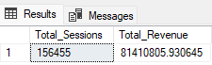

2 . What is the total revenue generated month-wise?
Business goal : Identify seasonal trends and monthly performance.
select MONTH as Month,
SUM(Charging_Cost_INR) as Total_Revenue
from dbo.EV_Charging
group by month
order by Month desc;

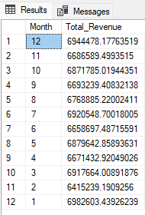

3 . Which charging hour has the highest no.of sessions?
Business goal : Identify peak charging hours.
SELECT COUNT(session_ID) as Total_Sessions,
charging_Hour as Peak_Hour
from dbo.EV_Charging
group by Charging_Hour
order by Total_Sessions DESC

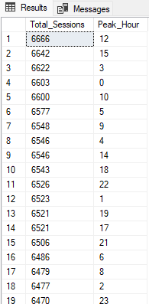

4. Which vehicle type generates the highest total Revenue?
Business goal : Understand which vehicle segment is more profitable.
select (Vehicle_Type) as vehicles,
sum(Charging_Cost_INR) as Total_Revenue
from dbo.EV_Charging
group by Vehicle_Type
order by Total_Revenue desc

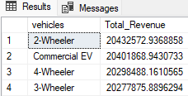

5. What is the average charging duration for each vehicle type?
Business goal : Compare charging behavior across vehicle types.
select AVG(Charging_Duration_Minutes) as Charging_duration,
vehicle_Type as Vehicle
from dbo.EV_Charging
group by Vehicle_Type
order by Charging_duration

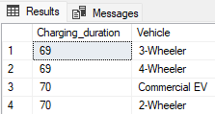

6. Which vehicle type consumes the highest total energy(kwh)?
Business goal : Analyze energy demand by vehicle category
select SUM(Energy_Consumed_kwh) as highest_total_energy,
Vehicle_Type as vehicle
from dbo.EV_Charging
group by Vehicle_Type
order by highest_total_energy

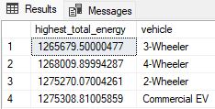

7. Which charging station generates revenue higher than the average revenue of all stations?(Top 5)
Business goal : Identify high-performing charging stations that outperform the network average
Select top 5 station_ID,
sum(charging_cost_INR) as Highest_revenue
from dbo.EV_Charging
group by Station_ID
having SUM(charging_cost_INR)>
(
select AVG(station_revenue)
from(select station_ID,
sum(charging_cost_INR) as station_revenue
from dbo.EV_Charging
group by Station_ID
)as t
)
order by Highest_revenue desc

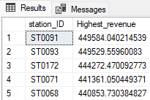

8. Which vehicle types have total energy consumption greater than overall average energy consumption across all vehicle categories?
Business goal : Detect vehicle segments that drive unusually high energy demand
select vehicle_Type,
SUM(Energy_consumed_kwh) as Total_energy_consumed
from dbo.EV_Charging
group by Vehicle_Type
having SUM (Energy_consumed_kwh)>
(
select AVG(Total_energy_consumed)
from(select vehicle_Type,
SUM(Energy_consumed_kwh) as Total_energy_consumed
from dbo.EV_Charging
group by Vehicle_Type
)as t
)
order by Total_energy_consumed desc

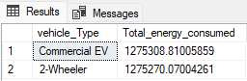

9. What is the month-over-month revenue growth percentage for the charging network?
Business goal : Analyze revenue trends and detect periods of growth or decline
with Monthly_Revenue as(
select
MONTH,
month_name,
SUM(charging_cost_inr) as Total_Revenue
from dbo.EV_Charging
group by Month,Month_Name
)
select MONTH,month_name,Total_Revenue,
LAG(Total_Revenue) over (order by Month) as Previous_Month_Revenue,

(
(Total_Revenue-LAG(Total_Revenue) over (Order by month))*100.0/LAG(Total_Revenue) over (Order by month)
)as MoM_Growth_Percentage
from Monthly_Revenue
order by Month
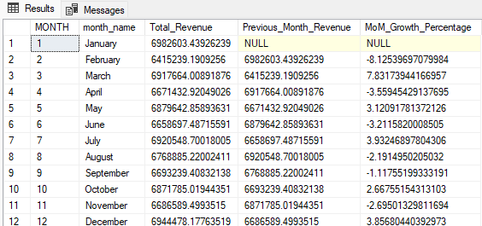

10. For each Month, Which are the top 2 vehicle types contributing the highest revenue?
Business goal : Understand monthly revenue leaders to optimize pricing and infrastructure planning
with Monthly_vehicle_revenue as(
select
MONTH,
Month_name,
vehicle_type,
sum(Charging_cost_inr) as Total_Revenue
from dbo.EV_Charging
group by Month,Month_Name,Vehicle_Type
),
Ranked_Data as (
select *,
RANK() over (
partition by month
order by Total_Revenue desc
)as revenue_rank
from Monthly_vehicle_revenue
)
select * from Ranked_Data
where Revenue_Rank <=2
order by Month,Revenue_rank

